Equipment Request & IT Operations

Human Resource

This module allow employees to send requests to HR department for equipments type of hardware and software.

**Available Features:**  
*\* Allow employee to request for hardware/software resource to HR department.  
  * Allow employee to request for damage hardware and expense integrated with HR expenses.  
  * Integrated with Warehouse.  
  * Print PDF report of Equipments.*  
  * HR can generate expense for damages.  
  * Stock user can generate internal transfer for equipment requess.  
**Workflow:**      * Draft->Waiting for Approval->Approved by Department->Approved by HR->Equipment Assigned->Refused->Rejected

**Menus Available:**

* *Equipments/Equipments*
* *Equipments/Equipments/My Equipment Requests*
* *Equipments/Equipments/Department Equipment Requests to Approve*
* *Equipments/Equipments/HR Equipment Requests to Approve*
* *Equipments/Equipments/Stock Equipment Requests to Approve*

Equipment Requests - Menu For Admin

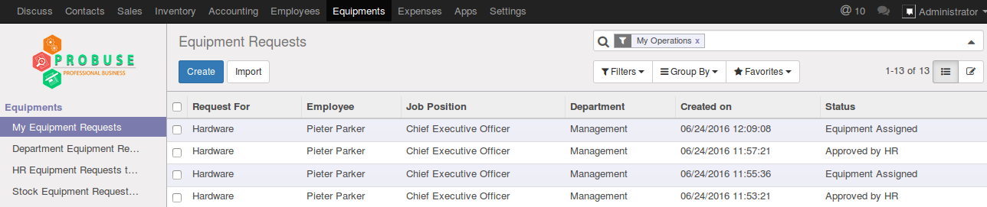

Equipment Requests - Menu For Employee

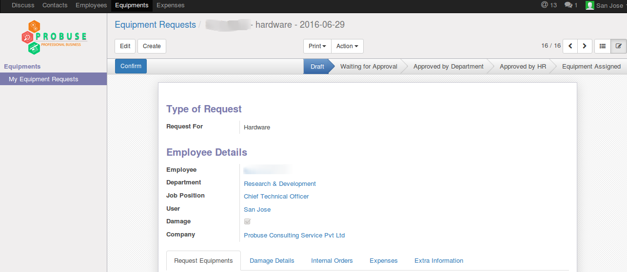

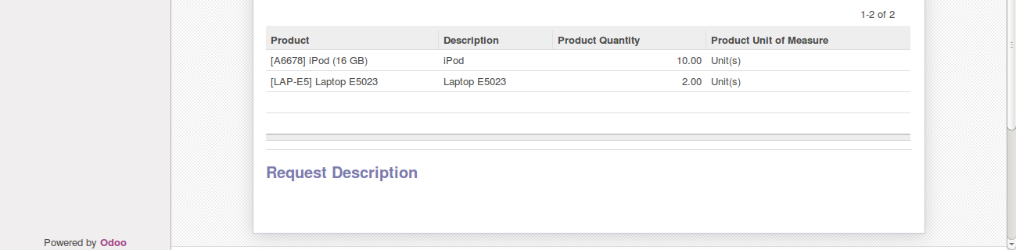

Equipment Damage Requests - Waiting For Approval Of Department

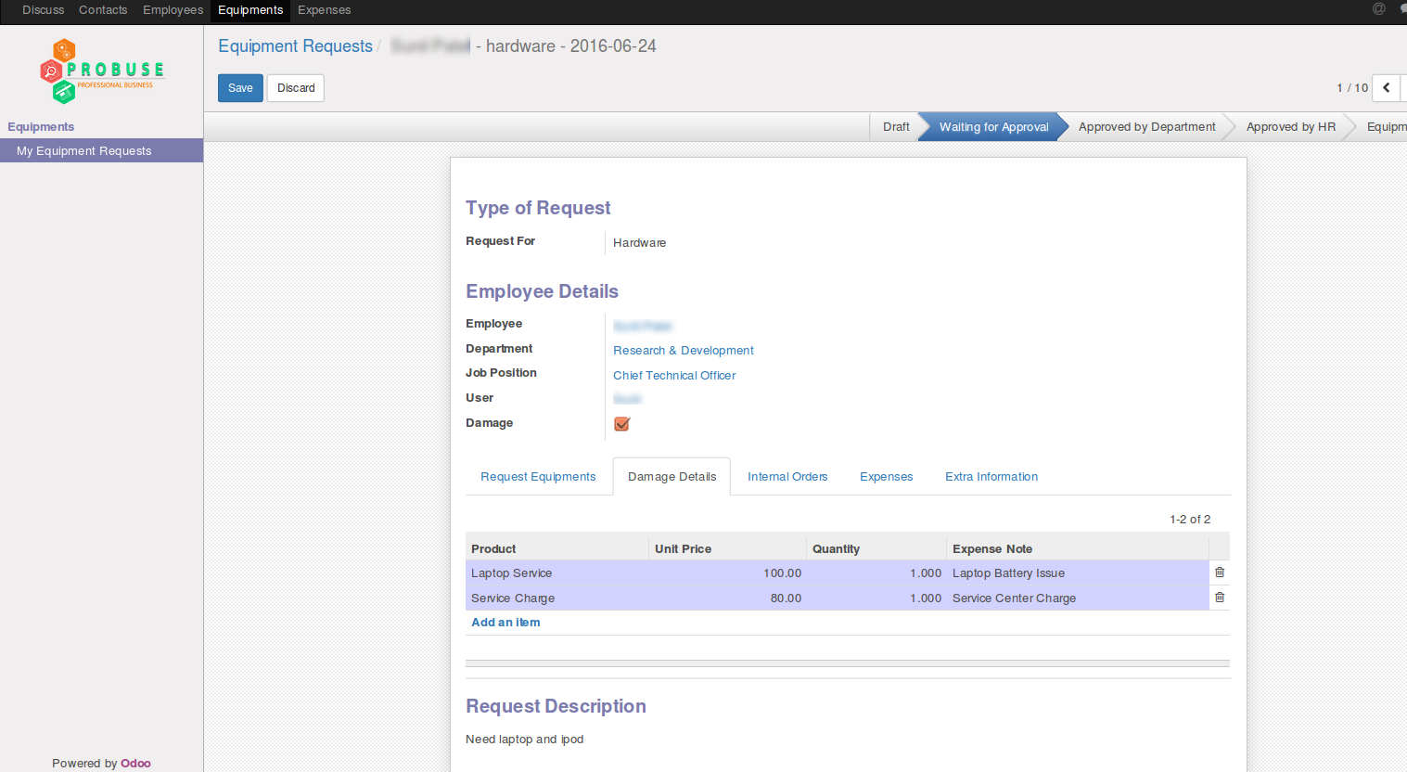

Generate Expense Button - Visible On Damage Request (Only For HR Officer)

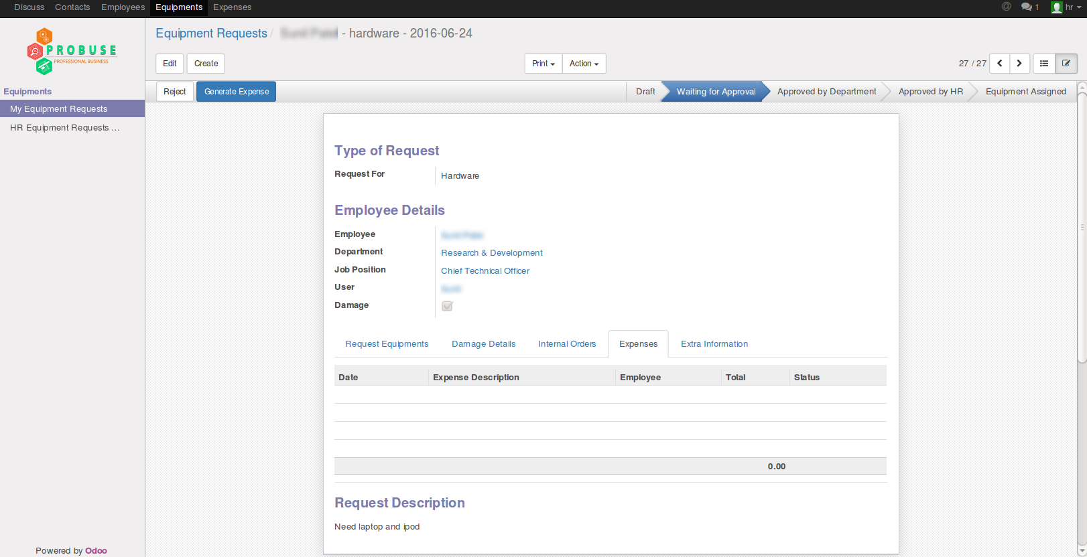

List of Generated Expenses

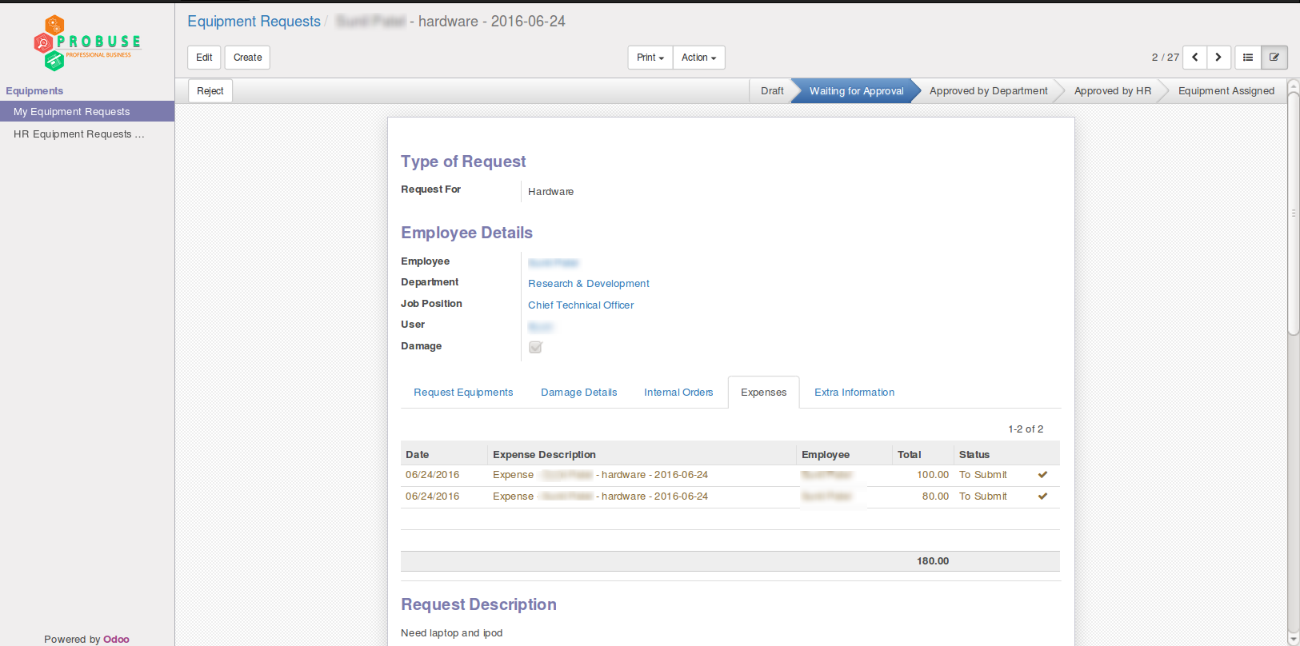

Approved By HR Department

Create internal transfer button for stock/warehouse user which will create internal picking.

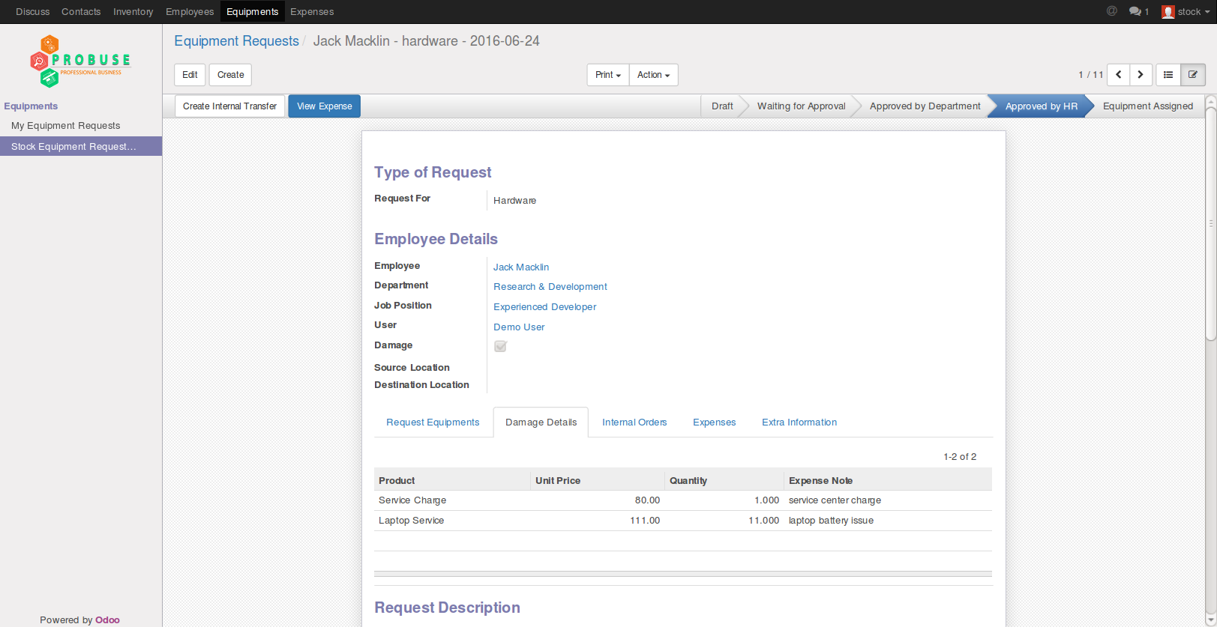

View Internal Transfer

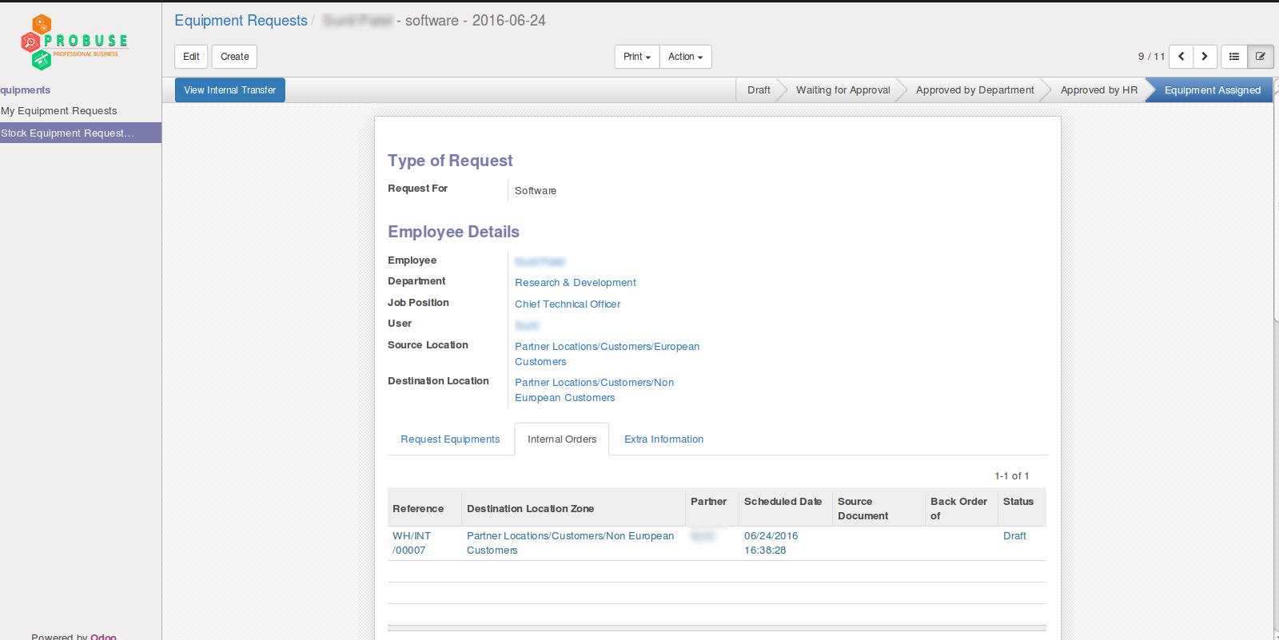

Internal Transfer Form

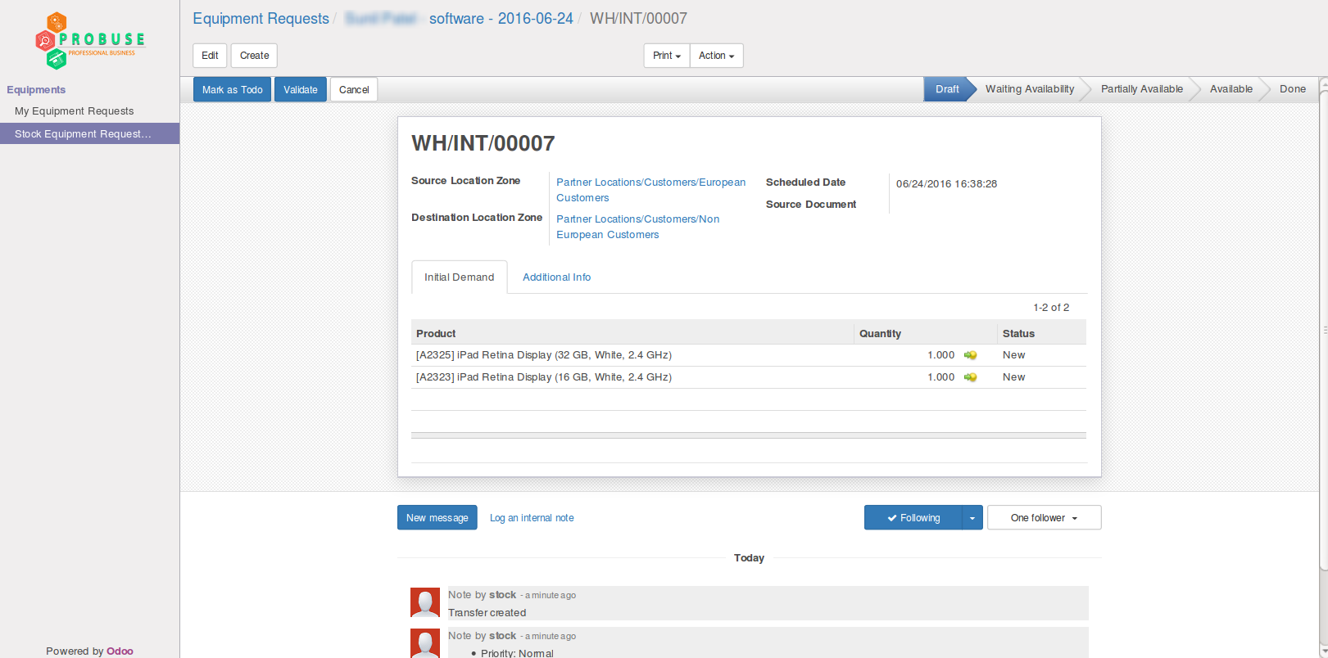

Department Manager Configuration

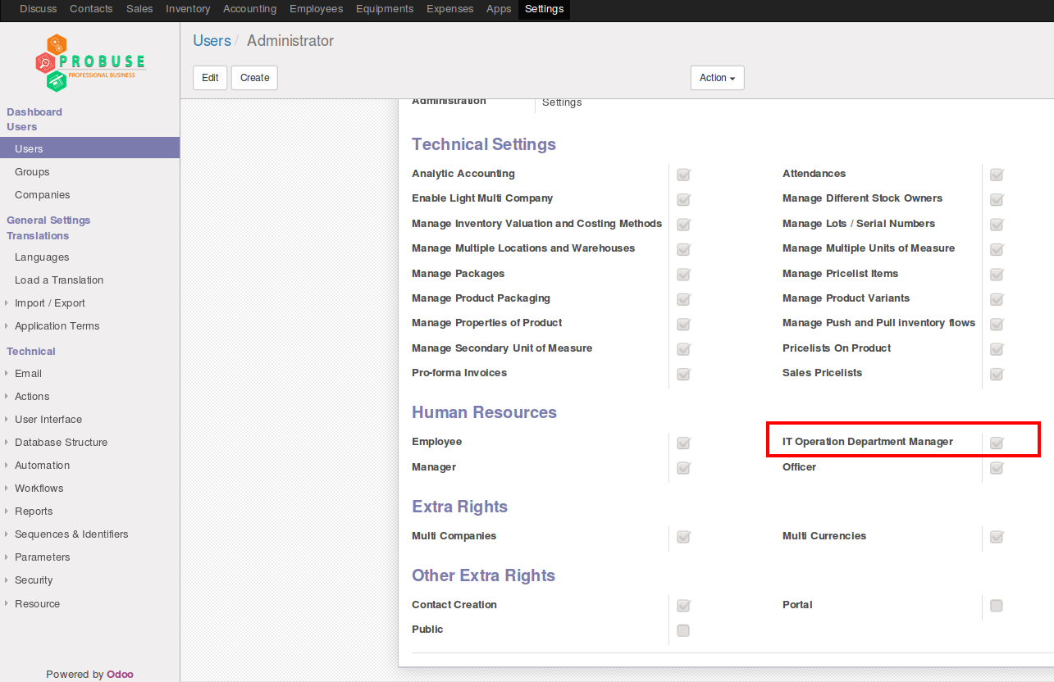

Print PDF Report

